**Project: Exploring Weather Trends – NYC vs. Global**

***Extract data from database using SQL***

1. See if there is data for New York City.

SELECT * FROM city_list where city LIKE '%New%';

1. Extract data for New York City:

SELECT * FROM city_data WHERE city = 'New York' ORDER BY year;

1. Extract global data:

SELECT * FROM global_data ORDER BY year;

***Line Chart***

1. Test how much moving average to use to smooth out the line: 3 year moving average, 5 year moving average, 7 year moving average, 10 year moving average.

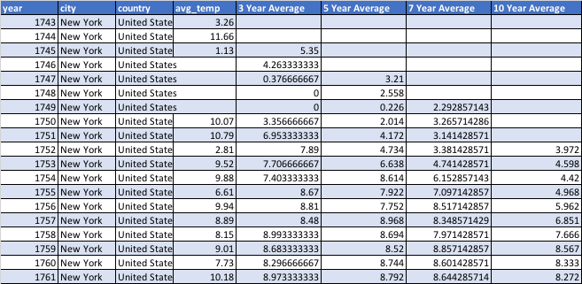

1. The “10 Year” moving average (blue line) smooths out the line better than the rest, so I will use this for comparing against the global moving average.
2. The global average temperature data starts at 1750 (NYC starts at 1743), so start the comparison at 1750 for both.

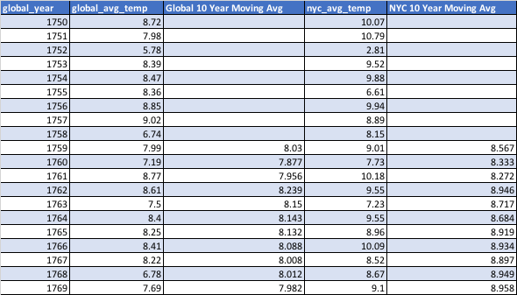

***Observations***

1. The global 10 year moving average line is “smoother” than the NYC moving average line. The most likely explanation is that the global average is made from more data points (345 cities are returned when using the query: SELECT COUNT(*) FROM city_list).
2. Besides colder temperatures in the late 1700s, on average the 10 Year Moving Average of New York City is 1 ºC GREATER than the Global Average (NYC is hotter than the global average).
   1. Besides the late 1700s, the 10 Year Moving Average for New York City roughly follows the same slope as the 10 Year Moving Average for the global temperature.
3. From 1750 to 2013, both the NYC moving average and Global moving average temperature have gone up nearly 2 ºC. The gains in the last 100 years (between 1900-2000) were greater than the previous 100 years (1800-1900).
4. The 10-year moving average temperature increase from the last 50 years (1963-2013) does **NOT** appear to be slowing down or leveling off. The consequences are unknown at this time, but could have grave impacts in the future.

